Novel Coronavirus(2019-nCoV)
Situation Report – 17 - ERRATUM

Data as reported by 6 February 2020*

HIGHLIGHTS

- No new countries reported cases of 2019-nCoV in the past 24 hours.
- WHO is working with partners to strengthen global diagnostic capacity for 2019- nCoV detection to improve surveillance and track the spread of disease. WHO and partners have activated a network of specialized referral laboratories with demonstrated expertise in the molecular detection of coronaviruses. These international labs can support national labs to confirm new cases and troubleshoot their molecular assays.
- WHO is convening a global research and innovation forum to mobilize international action in response to the new coronavirus, covering a broad spectrum of research areas including epidemiology, clinical care, vaccines, therapeutics, diagnostics, animal health, social sciences, and other topics. More details can be found here.

SITUATION IN NUMBERS
total and new cases in last 24 hours

Globally
28 276 confirmed (3722 new)

China
28 060 confirmed (3697 new)
3859 severe (640 new)
564 deaths (73 new)

Outside of China
216 confirmed (25 new)
24 countries
1 death

WHO RISK ASSESSMENT

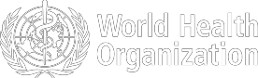
China | Very High
Regional Level | High
Global Level | High

Figure 1. Countries, territories or areas with reported confirmed cases of 2019-nCoV, 6 February 2020

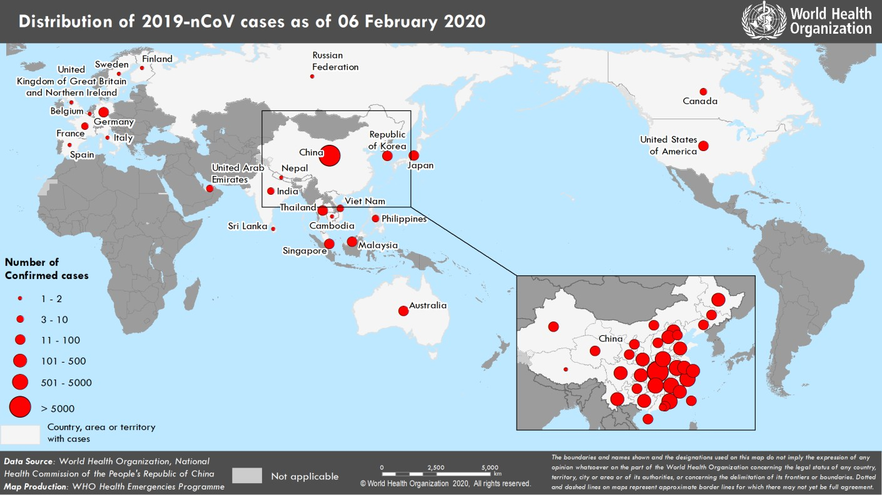

*The situation report includes information provided by national authorities as of 10 AM Central European Time

TECHNICAL FOCUS: Establishing global/regional coordination and technical guidance

WHO is working with partners to strengthen global diagnostic capacity for 2019-nCoV detection to improve surveillance and track the spread of disease. Public health efforts to control the spread of disease in countries with imported cases depend critically on the ability to detect the pathogen quickly. WHO and partners have activated a network of specialized referral laboratories with demonstrated expertise in the molecular detection of coronaviruses. These international labs can support national labs to confirm new cases and troubleshoot their molecular assays.

Currently, there are 15 laboratories have been identified to provide reference testing support for 2019-nCoV. These laboratories include:
- Armed Forces Research Institute of Medical Sciences, Thailand
- Erasmus Medical Center, The Netherlands
- Hong Kong University, Hong Kong SAR, China
- Institute of Tropical Medicine, Nagasaki University, Japan
- Institute of Virology, Charité, Robert Koch Institute, Germany
- National Institute for Communicable Diseases, South Africa
- National Institute of Health, Thailand
- National Institute of Virology, India
- National Public Health Laboratory, Singapore
- Institut Pasteur Dakar, Senegal
- Institut Pasteur, Paris
- Public Health England, UK
- State Research Center for Virology and Biotechnology, Vector Institute, Russia
- United States Center for Disease Control and Prevention, USA
- Victorian Infectious Diseases Reference Laboratory, Australia

WHO is working to ensure 2019-nCoV test availability, including: a) screening of 2019-nCoV PCR protocols from academic laboratories for validation data, b) evaluation of the potential to use existing commercial coronavirus assays (e.g. SARS-CoV) to detect 2019-nCoV with high sensitivity, and c) working with commercial and non- commercial agencies with capacity to manufacture and distribute newly-developed 2019-nCoV PCR assays. To increase regional testing capacity, efforts to increase national capacity and provide regional reference laboratory support is ongoing. WHO has made 250,000 tests available to WHO Regional Offices and national laboratories. These tests are being shipped to 159 laboratories across all WHO regions.

WHO will also utilize the Shipping Fund Programme established by the Global Influenza Surveillance and Response System as a mechanism to send clinical samples from patients meeting the case definition of suspected 2019-nCoV infection to international referral laboratories.

National capacity for detection of 2019-nCoV must be strengthened so that diagnostic testing can be performed rapidly without the need for overseas shipping. One way this will be achieved is by working with existing global networks for detection of respiratory pathogens, such as National Influenza Centres.
SURVEILLANCE

Table 1. Confirmed cases of 2019-nCoV acute respiratory disease reported by provinces, regions and cities in China, 6 February 2020

Province/Region/City | Confirmed Cases
Hubei | 19 665
Zhejiang | 954
Guangdong | 944
Henan | 851
Hunan | 711
Anhui | 591
Jiangxi | 600
Chongqing | 389
Jiangsu | 373
Sichuan | 321
Shandong | 343
Beijing | 274
Shanghai | 254
Fujian | 215
Heilongjiang | 227
Shaanxi | 173
Guangxi | 168
Hebei | 157
Yunnan | 128
Hainan | 100
Liaoning | 89
Shanxi | 90
Tianjin | 70
Gansu | 62
Guizhou | 69
Jilin | 59
Inner Mongolia | 46
Ningxia | 40
Xinjiang | 36
Hong Kong SAR | 21
Qinghai | 18
Taipei and environs | 11
Macao SAR | 10
Xizang | 1
Total | 28 060

Table 2. Countries, territories or areas with reported confirmed 2019-nCoV cases and deaths. Data as of 6 February 2020

Confirmed
WHO Region | Country/Territory/Area | *  (new) cases | Total (new) cases with travel history to China | Total (new) cases with possible or confirmed transmission  † | Total (new) cases with site of transmission under investigation | Total (new) deaths
Western Pacific Region | China‡ | 28 060(3697) |  |  |  | 564 (73)
Western Pacific Region | Singapore | 28 (4) | 21 (1) | 7 (3) | 0 (0) | 0
Western Pacific Region | Japan | 25 (2) | 21 (1) | 4 (1) | 0 | 0
Western Pacific Region | Republic of Korea | 23 (5) | 10 (1) | 11 (3) | 2 (1) | 0
Western Pacific Region | Australia | 14 (1) | 14 (1) | 0 (0) | 0 (0) | 0
Western Pacific Region | Malaysia | 12 (2) | 9 (2) | 2 (0) | 1 (0) | 0
Western Pacific Region | Viet Nam | 10 (0) | 7 (0) | 3 (0) | 0 (0) | 0
Western Pacific Region | Philippines | 3 (0) | 2 (0) | 0 (0) | 1 (0) | 1
Western Pacific Region | Cambodia | 1 (0) | 1 (0) | 0 (0) | 0 (0) | 0
South-East Asia Region | Thailand | 25 (0) | 21 (0) | 4 (0) | 0 (0) | 0
South-East Asia Region | India | 3 (0) | 3 (0) | 0 (0) | 0 (0) | 0
South-East Asia Region | Nepal | 1 (0) | 1 (0) | 0 (0) | 0 (0) | 0
South-East Asia Region | Sri Lanka | 1 (0) | 1 (0) | 0 (0) | 0 (0) | 0
Region of the Americas | United States of America | 12 (1) | 10 (1) | 2 (0) | 0 (0) | 0
Region of the Americas | Canada | 5 (0) | 3 (0) | 0 (0) | 2 (0) | 0
European Region | Germany | 12 (0) | 2 (0) | 10 (0) | 0 (0) | 0
European Region | France | 6 (0) | 5 (0) | 1 (0) | 0 (0) | 0
European Region | Italy | 2 (0) | 2 (0) | 0 (0) | 0 (0) | 0
European Region | Russian Federation | 2 (0) | 2 (0) | 0 (0) | 0 (0) | 0
European Region | The United Kingdom | 2 (0) | 1 (0) | 1 (0) | 0 (0) | 0
European Region | Belgium | 1 (0) | 1 (0) | 0 (0) | 0 (0) | 0
European Region | Finland | 1 (0) | 1 (0) | 0 (0) | 0 (0) | 0
European Region | Spain | 1 (0) | 0 (0) | 1§ (0) | 0 (0) | 0
European Region | Sweden | 1 (0) | 1 (0) | 0 (0) | 0 (0) | 0
Eastern Mediterranean Region | United Arab Emirates | 5 (0) | 5 (0) | 0 (0) | 0 (0) | 0
Other | Cases on an international conveyance (Japan) | 20**(10) | 0(0) | 0(0) | 20 (10) | 0

outside of China

*Case classifications are based on WHO case definitions for 2019-nCoV.
†Location of transmission is classified based on WHO analysis of available official data, and may be subject to reclassification as additional data become available.
‡Confirmed cases in China include cases confirmed in Hong Kong SAR (21 confirmed cases, 1 death), Macao SAR (10 confirmed cases) and Taipei and environs (11 confirmed cases).
§The exposure occurred in Germany.
**Cases identified on a cruise ship currently in Japanese territorial waters.

ERRATUM – Due to a typographical error, the death previously reported in the Philippines was inadvertently placed under Cambodia. It has been corrected here.

Figure 2: Epidemic curve of 2019-nCoV cases (n=109) identified outside of China, by date of onset of symptoms and travel history, 6 February 2020
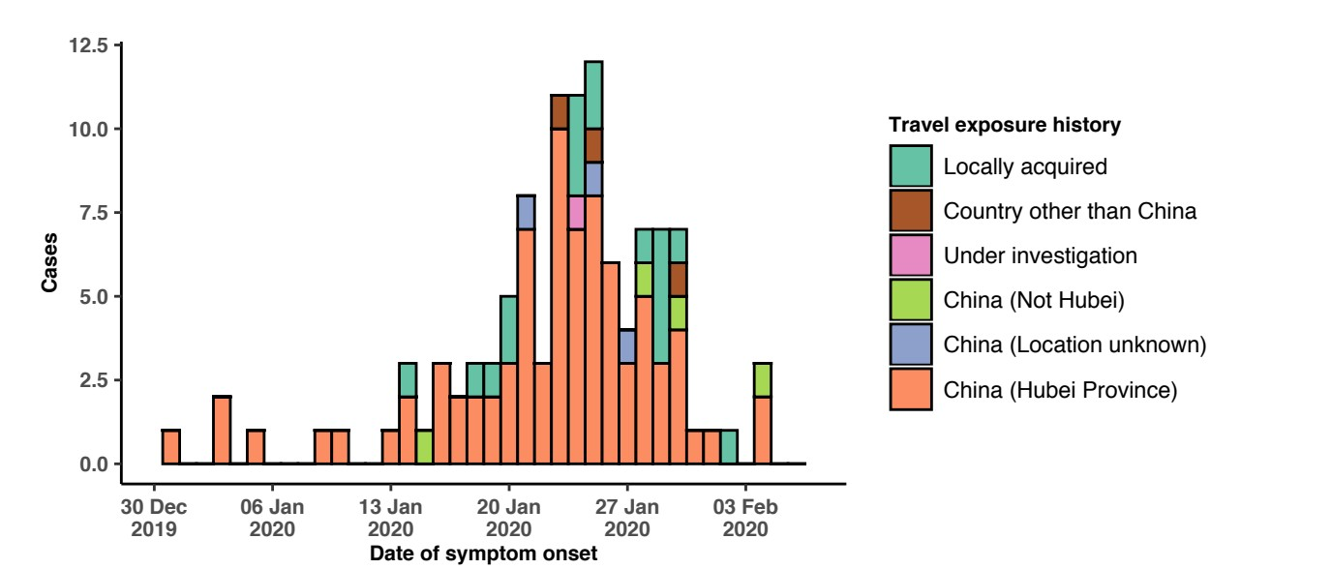

Note for figure 2: Of the 216 cases reported outside China, 15 were detected while asymptomatic. For the remaining 201 cases, information on date of onset is available only for the 109 cases presented in the epidemiologic curve.

Figure 3: Epidemic curve of 2019-nCoV cases (n=216) identified outside of China, by date of reporting and travel history, 6 February 2020
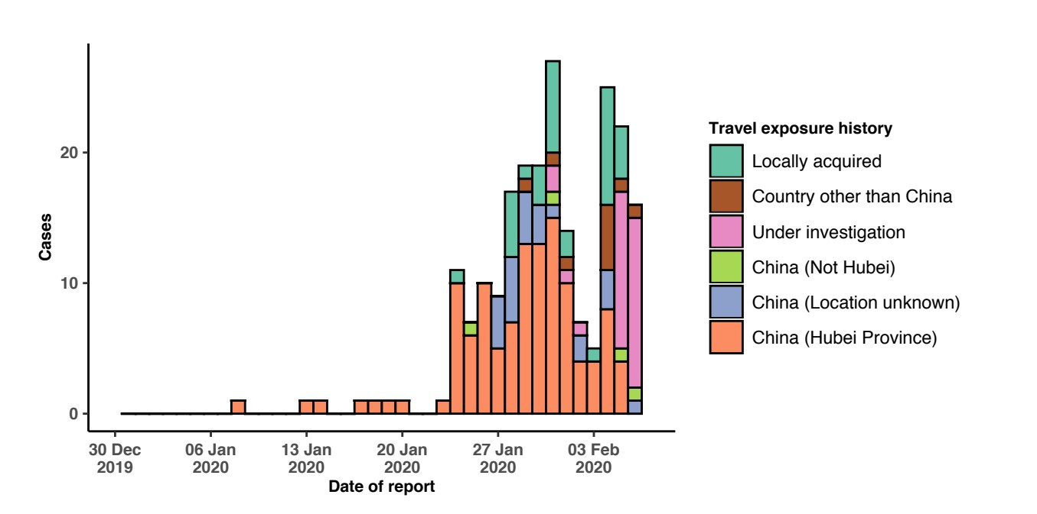

STRATEGIC OBJECTIVES

WHO’s strategic objectives for this response are to:

  - Limit human-to-human transmission including reducing secondary infections among close contacts and health care workers, preventing transmission amplification events, and preventing further international spread from China*;
  - Identify, isolate and care for patients early, including providing optimized care for infected patients;
  - Identify and reduce transmission from the animal source;
  - Address crucial unknowns regarding clinical severity, extent of transmission and infection, treatment options, and accelerate the development of diagnostics, therapeutics and vaccines;
  - Communicate critical risk and event information to all communities and counter misinformation;
  - Minimize social and economic impact through multisectoral partnerships.

*This can be achieved through a combination of public health measures, such as rapid identification, diagnosis and management of the cases, identification and follow up of the contacts, infection prevention and control in healthcare settings, implementation of health measures for travellers, awareness- raising in the population and risk communication.

PREPAREDNESS AND RESPONSE

- WHO is working closely with International Air Transport Association (IATA) and have jointly developed a guidance document to provide advice to cabin crew and airport workers, based on country queries. The guidance can be found on the IATA webpage.
- WHO has developed a protocol for the investigation of early cases (the “First Few X (FFX) Cases and contact investigation protocol for 2019-novel coronavirus (2019-nCoV) infection”). The protocol is designed to gain an early understanding of the key clinical, epidemiological and virological characteristics of the first cases of 2019- nCoV infection detected in any individual country, to inform the development and updating of public health guidance to manage cases and reduce potential spread and impact of infection.
- WHO has been in regular and direct contact with Member States where cases have been reported. WHO is also informing other countries about the situation and providing support as requested.
- WHO has developed interim guidance for laboratory diagnosis, advice on the use of masks during home care and in health care settings in the context of the novel coronavirus (2019-nCoV) outbreak, clinical management, infection prevention and control in health care settings, home care for patients with suspected novel coronavirus, risk communication and community engagement and Global Surveillance for human infection with novel coronavirus (2019-nCoV).
- WHO has prepared disease commodity package that includes an essential list of biomedical equipment, medicines and supplies necessary to care for patients with 2019-nCoV.
- WHO has provided recommendations to reduce risk of transmission from animals to humans.
- WHO has published an updated advice for international traffic in relation to the outbreak of the novel coronavirus 2019-nCoV.
- WHO has activated of R&D blueprint to accelerate diagnostics, vaccines, and therapeutics.
- WHO has developed an online course to provide general introduction to emerging respiratory viruses, including novel coronaviruses.
- WHO is providing guidance on early investigations, which are critical to carry out early in an outbreak of a new virus. The data collected from the protocols can be used to refine recommendations for surveillance and case definitions, to characterize the key epidemiological transmission features of 2019-nCoV, help understand spread,
severity, spectrum of disease, impact on the community and to inform operational models for implementation of countermeasures such as case isolation, contact tracing and isolation. Several protocols are available here: https://www.who.int/emergencies/diseases/novel-coronavirus-2019/technical-guidance/early-investigations
- WHO is working with its networks of researchers and other experts to coordinate global work on surveillance, epidemiology, modelling, diagnostics, clinical care and treatment, and other ways to identify, manage the disease and limit onward transmission. WHO has issued interim guidance for countries, which are updated regularly.
- WHO is working with global expert networks and partnerships for laboratory, infection prevention and control, clinical management and mathematical modelling.

RECOMMENDATIONS AND ADVICE FOR THE PUBLIC

During previous outbreaks due to other coronavirus (Middle-East Respiratory Syndrome (MERS) and Severe Acute Respiratory Syndrome (SARS), human-to-human transmission occurred through droplets, contact and fomites, suggesting that the transmission mode of the 2019-nCoV can be similar. The basic principles to reduce the general risk of transmission of acute respiratory infections include the following:

- Avoiding close contact with people suffering from acute respiratory infections.
- Frequent hand-washing, especially after direct contact with ill people or their environment.
- Avoiding unprotected contact with farm or wild animals.
- People with symptoms of acute respiratory infection should practice cough etiquette (maintain distance, cover coughs and sneezes with disposable tissues or clothing, and wash hands).
- Within healthcare facilities, enhance standard infection prevention and control practices in hospitals, especially in emergency departments.

WHO does not recommend any specific health measures for travellers. In case of symptoms suggestive of respiratory illness either during or after travel, travellers are encouraged to seek medical attention and share their travel history with their healthcare provider.

